Meat Content Analysis

- Thaw out 5-10 samples
- Label Aluminum and petri dishes with numbers from samples that are being thawed out
- Cut along seams of the 2 joints to remove both knuckles leaving a straight edge (with 2 protrusions) on one side and a 45 degree angle on the other side of the merus
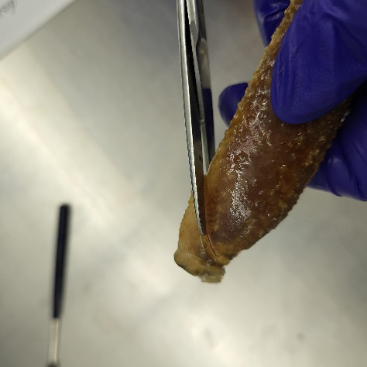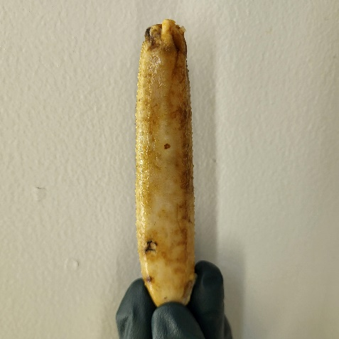

- Measure length of merus
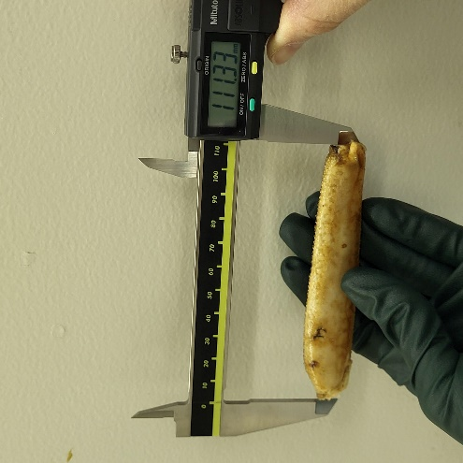

- Measure Width of largest area of merus
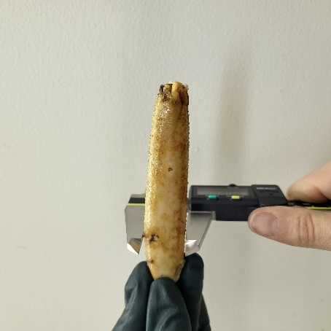
- Weigh merus
- Cut out a flap of shell on the flat side of merus
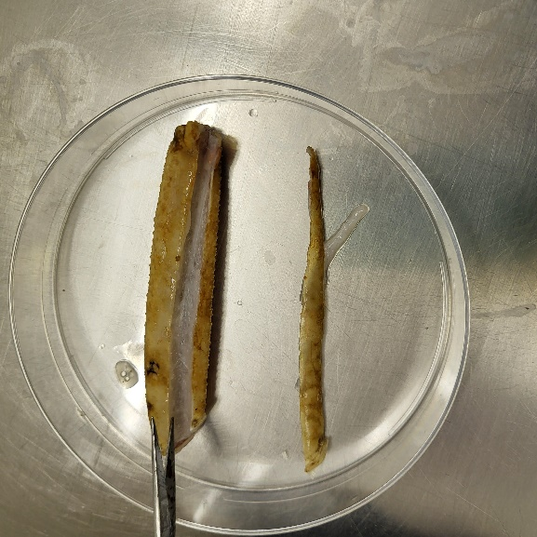

- Scrape out the tissue from the leg and flap and place in aluminum dish
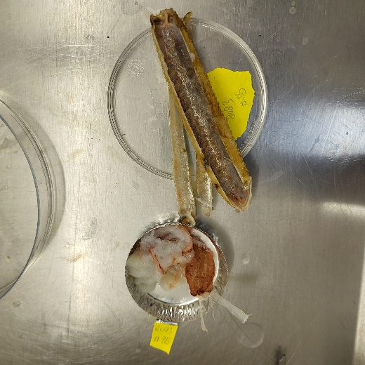

- Weigh the tissue
- Place the empty shells in a petri dish
- Weigh the empty shell

